VAIP Phone Camera
-------Quick operation guide

- Know your VAIP Phone
- General appearance
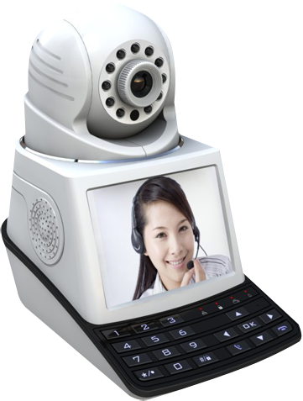

- Camera
- Screen
- The front panel: LED indicator & buttons
- The front panel
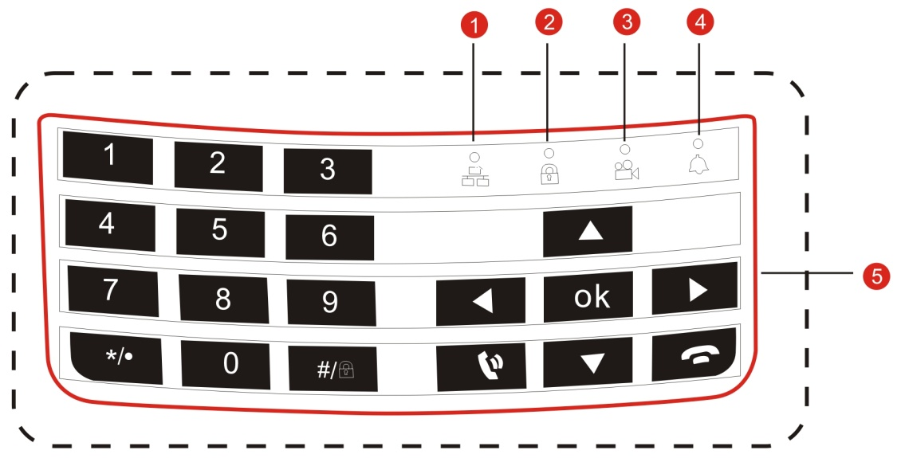
①Network indicator ②Defence indicator ③Record indicator
④Alarm indicator ⑤Button area
- Number button 0-9: Input the number key during user input state.
- Button: Short press to decrease the volume during video call or playing state.
Short press to delete text during edit state.
Long press to start/stop recording during manual record mode.
- Button :Short press to increase the volume during video call or playing state.
Short press to switch input method during edit state.
Long press to do defense/cancel operation during manual recording mode.
- Button: Short press to dial video call during standby state.
Long press to enter real-time preview during standby mode.
Short press to call logs page.
On the video call state,point this button,you can close your video,just transfer
the voice.
- Button: Hang up call during video call.
Short press to the previous menu or exit menu when main menu or submenu is popped.
Short press to exit when playback and preview state.
- Direction button
Remove the cursor by up and down buttons when the main menu or submenu is popped.
Add or decrease number during edit state.
Short press to change the settings .
Short press to play last video file during the playback state.
Short press to adjust the camera up and down during the standby , preview , video call status .
Remove the cursor by up and down buttons when the main menu or submenu is popped,Add or decrease number during edit state.
Short press to change the settings .
Short press to play last video file during the playback state.
Short press to adjust the camera up and down during the standby , preview and video call status .
Remove the cursor by up and down buttons when the main menu or submenu is popped.
Short press to fast reverse during playback status.
Short press to adjust the camera up and down during the standby , preview and video call status.
Remove the cursor by up and down buttons when the main menu or submenu is popped.
Short press to fast- forward during playback status.
Short press to adjust the camera up and down during the standby , preview and video call status.
- Ok button: Confirm. Enter the main menu.
Short press to pause playback during playback status.
Short press to switch the video screen during video call status.
- Quick connection 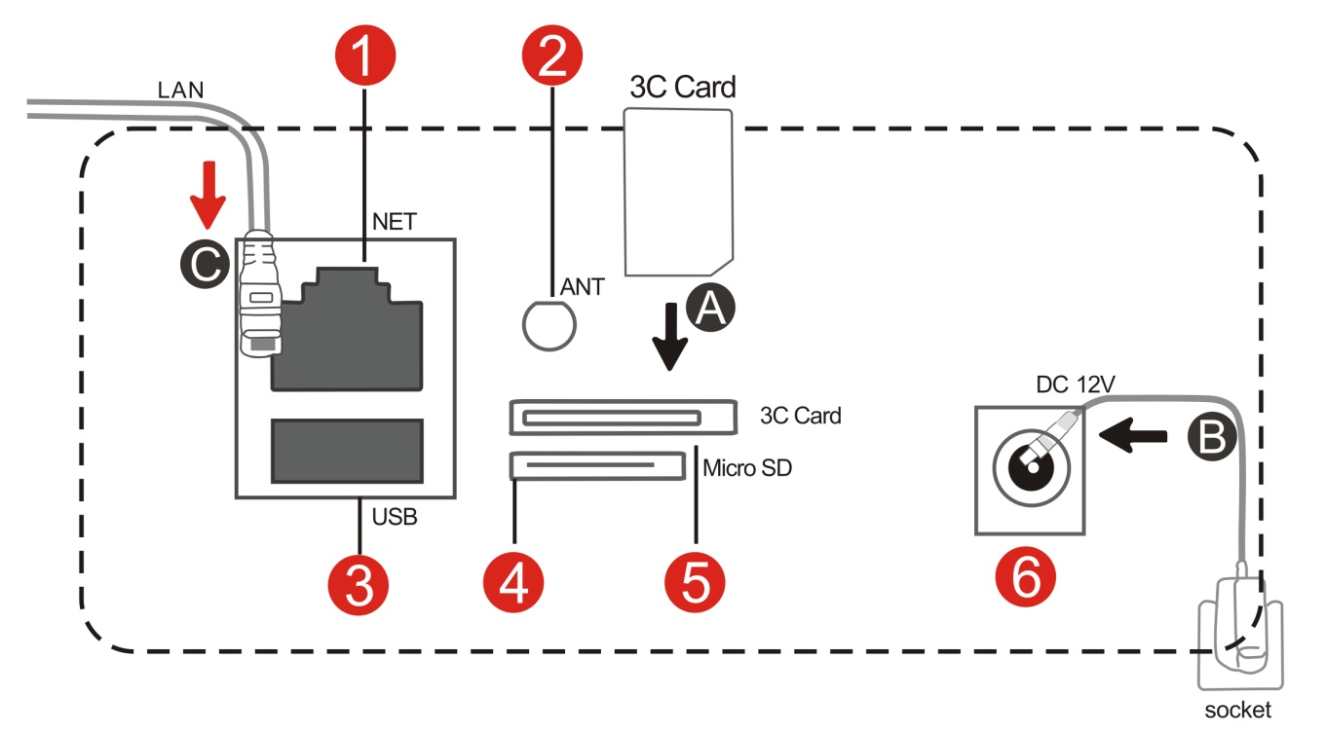
- Network interface: Connect internet by using the wired network.
- Antenna interface: Receive WIFI signal.
- USB interface: Insert U disk, device can store videos/pictures or update the system.
- SD card interface: Insert SD card, device can store videos/pictures.
- 3C smart card interface: Insert 3C smart card can get the 3C ID number.
- Power supply interface: Connect power adapter.
When use quick connection, please connect it according to the sequence of above picture A.B. If use wired network, please connect it according to the sequence of above picture A.B.C.
- Network connection
- Wired connection
- Please see (2. Fast connection) for connecting to internet.
- Please click【Main menu】>【Network】, choose “Network > Wired”,
will be shown in standby interface after successful connection.
- WiFi connection(Optional)
- Please click 【Main menu】>【Network】and choose “Network> WiFi”.
- Please click “OK” button to set WiFi, choose “search” button to search WiFi and connect it,  will be shown in standby interface after successful connection.
- Change the remote monitor password
In order to keep network safe, please change the remote access password after device connect to internet. The specific operation as follows: please click【Main menu】>【General】and choose “password”, then press “OK” button to change the password.
- Learn code(Optional)
1. Learning code with Wireless detector and remote control.
All the wireless detectors must learn code with the device for normal usage. The specific operation as follows:
Please download and install APP from www.2cu.co, add the device to contact list after registration and successful login, click contact name->control->defense setup; for example to set up a door sensor as No. 1 detector of the hall, choose the hall, click No. 1 button, the learning code dialog box will be popped up, then the door sensor will be triggered and APP will remind that the learning is successful.The No.1 button will turn to be light blue color.
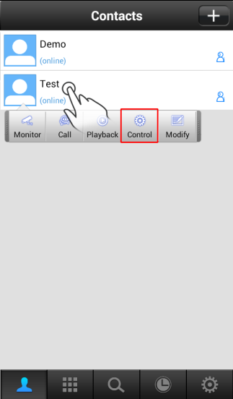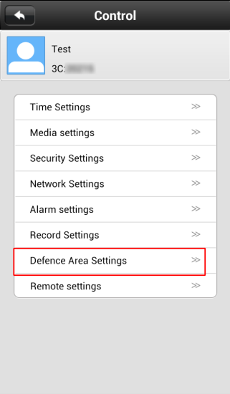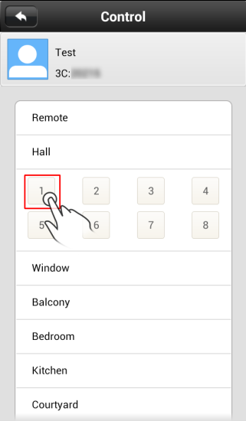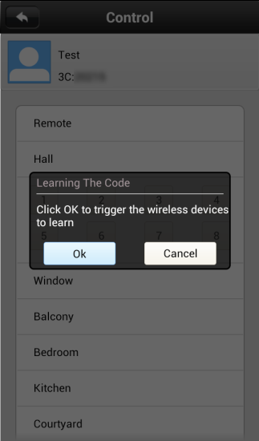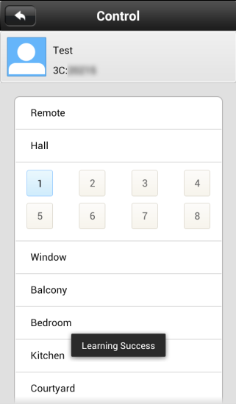
2.Wireless detector & remote control
A. Delete a detector of a group of numbers: click the associated digital and confirm to delete.
B. Delete all detectors of a group of numbers: long press the group name and confirm to delete.
Wireless controller key instruction : A setup defence B Disarming C Urgent alarm
- Download App
IOS clients can search and download 2CU from Apple APP Store,
Android clients can download 2CU from www.2cu.co

Learning code with Wireless detector and remote control.
All the wireless detectors must learn code with the device for normal usage. The specific operation as follows:
Please download and install APP from App store and google play, add the device to contact list after registration and successful login, click contact name->control->defense setup; for example to set up a door sensor as No. 1 detector of the hall, choose the hall, click No. 1 button, the learning code dialog box will be popped up, then the door sensor will be triggered and APP will remind that the learning is successful.
The No.1 button will turn to be light blue color. And it is same step for setting the romote,choose remote,then do the same step.it can learning successful

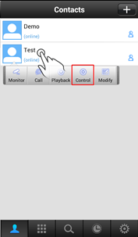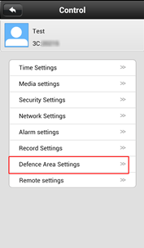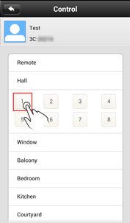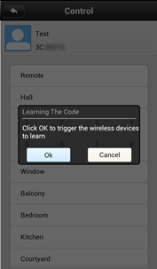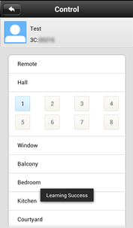

Read and understand thoroughly this safety awareness & instruction before using and keep it for future reference,the device is called VAIP in this text.

Safety Precaution:
Do not place heavy object on the VAIP.
Do not let any solid or liquid fall into or infiltrate the VAIP.
Do not disassemble, repair or replace the parts of the VAIP by yourself.

Using environment:
Please place and use the VAIP between 0℃ and 40 ℃.Avoid direct sunlight or stay away from heat.
Do not install the VAIP in damp environment.
Do not expose the VAIP in smoky or dusty environment.
Do not drop the VAIP and avoid strongly collision.
Please insure the VAIP level installation in a stable workplace and prevent the VAIP to be dropped.
Please install in well-ventilated place. Do not block the vents.
The VAIP only can be used within the range of rated input and output.

Contents
Contents ….………………………………………………………………………….…………..…….2
1 Product Introduction …….……………………………………………………………..……..…..4
1.1 Product overview ………….…………………………………………………………….….4
1.2 Main fuctions …………….………………………………………………….……………….4
2 Open-package check and cable connection ….……………………………….……………...5
2.1 Open-package check …..………………………………………………….……………..5
2.2 The front panel and rear panel …………………………………………….………….…6
2.3 Button function of the front and front panel ……………………………………………….7
2.4 The rear panel ………………………………………………….……………………..…11
3 Basic operation …………………………………………………………………………………...12
3.1 Turn on …………………………………………………………………………………...12
3.2 Turn off ……………………………………………………….………………………..…12
3.3 Standby state ………………………………………………………………………………14
4 Main menu ……………………………………………………………………………….……..….15
4.1 Main menu navigation …………………………………………………………………..16
4.2 General setup ……………………………………………………………………………17
4.3 System setup …….……………………………………………………..……….……...…18
4.4 Playback ………………………………………………………………………......……….21
4.5 Network setup …………………………………………………………………..…………23
4.6 Alarm setup ………………………………………………………………………………26
4.7 Record setup …………………………………………………………………..…………..28
5 Remote access & video calls ……………………………………………………………….….30
5.1 Remote monitor …………………………………………………………………..………..30
5.2 Video call ……………………………………………………………………………...……33
5.3 Recent phone records and address book ……………………………………...……35
6 The wireless match(some models without this function) ………………………..…………37
6.1 Wireless detector & remote control and device match code …………………………37
6.2 Remote wireless detector and remote control………………………..………………..39
7 FAQ and maintenance ………………………………………………….………………………..39
7.1 Frequently asked questions …………………………………….………………..………39
7.2 Maintenance……………………………………………………….……….………………44
7.3 Specification……………………………………………………….……….………………45

1 Product Introduction
1.1 Product Overview
The VAIP series is a type of excellent intelligent home product specially designed for digital field. It introduces embedded LINUX operating system which is more stable. It introduces the technology of standard H.264 mp video compression format and G.711A audio compression format which insure the high-quality image, low-bit rate and single-frame playing. It introduces Cloudlink P2P network transmission technology which achieves strong network data transmission ability and remote control ability. It introduces wireless match codes technology and wireless detector to construct a strong alarm system.
1.2 Main functions
Video call
It can realize the video call not only between two VAIP, but also among smart phone, tablet computer and VAIP.
Record function
After inserting U disk or Micro SD to VAIP, it can realize simultaneous storage and recording of audio and video, and different recording mode such as manual recording, alarm recording, timing recording can be selected.
You can search video files intelligent on the device and playback video on the screen directly.
Remote monitor
It can achieve remote monitor by using mobile APP to dial 3C number.At the same time can remote control the equipment’s moving .
Wireless alarm
It introduces wireless match code and wireless detector to construct alarm system, and also email alarm function is supported.
2 Open-package inspection and cable connection
2.1 Open package check
First, please check whether there is any visible damage to the package appearance. The protective material used for the package of the VAIP can sustain most accidental clashes during the transportation.
Then, please open the box and get rid of the plastic protective coating. Check whether there is any visible damage to the VAIP appearance.
2.2 The front panel and rear panel
The key function specification in the front panel and the interface specification in the rear panel are described in details in the manual.
Please check carefully the product model in the bottom plate or in the rear panel film whether is accordant with the model you ordered.
The label in the bottom plate or in the real panel is very important for after-sales service, please protect it carefully.
Please provide the product model and serial number in the label before you contact with our after sales.

2.3 The front panel key function
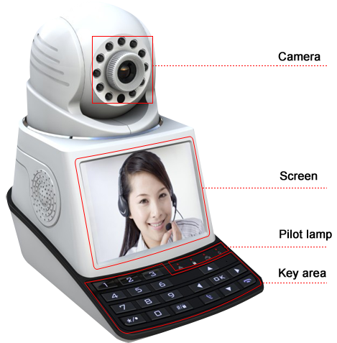
Pilot lamp:From left to right are： (Network, Defence,Recording, Alarm).
The front button operation function

Num | Button name | Mark | Function
1 | Number button | 0-9 | - Input the number key during user input state
2 | */. | 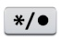 | - Short press to decrease the volume during video call or playing state
2 | */. |  | - Short press to delete text during edit state
2 | */. |  | - Long press to record/stop recording during manual record mode
3 | Ctrl shift/  defense | 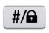 | - Short press to increase the volume during video call or playing state
3 | Ctrl shift/  defense |  | - Short press to switch input method during edit state
3 | Ctrl shift/  defense |  | - Long press to do defense/cancel operation
4 | Dial/preview | 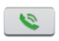 | - Short press to dial video call during standby state
4 | Dial/preview |  | - Long press to enter real-time preview during standby mode
4 | Dial/preview |  | - On the video call state,point this button,you can close your video,just transfer the voice
4 | Dial/preview |  | - Short press to the call logs page during standby mode
5 | Hang up/Exit | 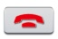 | - Hang up call during video call
5 | Hang up/Exit |  | - Back to above level menu and exit current state
5 | Hang up/Exit |  | - Short press to do main menu quit during playback and preview
6 | Direction button |    | - Remove the cursor by up and down buttons when the main menu or submenu is popped
6 | Direction button |  | - Change the setting in the menu
6 | Direction button |  | - Play last or next video file by up and down buttons during the playback state
6 | Direction button |  | - Short press to adjust camera up or down direction during standby, preview, video call state.
6 | Direction button |    | - Move the cursor by left and right buttons when the main menu or submenu is popped
6 | Direction button |  | - Play in the multi-low or multi-fast video during the playback state
6 | Direction button |  | - Short press to adjust camera left or right direction during standby, preview, video call state
6 | Direction button | 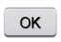 | - Enter main menu
6 | Direction button |  | - Confirm
6 | Direction button |  | - Short press to pause playing during playback state
6 | Direction button |  | - Short press to do screen switching during video call

2.4 The rear panel
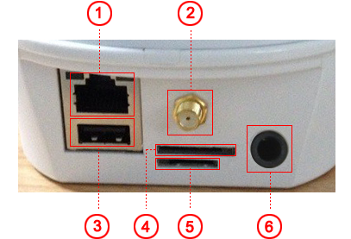
①Network interface ②WIFI ant interface(optional) ③USB interface ④vaip card interface ⑤Micro SD ⑥Power interface

3 Basic operation
3.1 Turn on
Plug the power supply and turn on the power supply switch to “ON”, then the VAIP enters the system.
Suggest using the stable input voltage and power input ripple with less interference to make sure the VAIP power supply.
Suggest using the UPS to protect the power supply under allowable conditions
3.2 Turn off
Check and confirm the recording is stopped before turn off the VAIP, turn off the power supply switch to “OFF”, or pull the rear panel power switch that can switch power.
Auto resume after power failure
If the VAIP is shut down abnormally under recording state, it can automatically backup video and resume previous working status after power failure.
Insert the U disk or Micro SD card
Please make sure the VAIP is not in recording state before inserting the U disk or Micro SD card, otherwise information will loss or storage equipment will be damaged.

Replace the battery
Please save the setting information and turn off the power supply switch before replacing the battery. The VAIP uses button battery. Please check the system time regularly, if the time is not correct, you need replace the battery. Suggest replacing the battery every year and using the same type battery.
Note: The setting information must be saved before replacing the battery, otherwise information will lose.

3.3 Standby state
Turn on the VAIP and enter standby state, the system standby is shown as below.

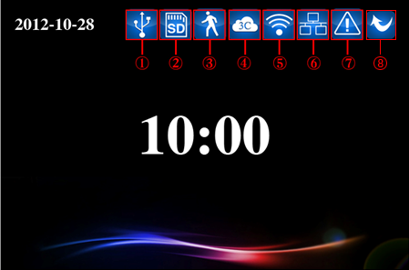
Picture 3.1 Standby interface

Icons meaning under standby state:

1 |  | USB detection icon | 2 |  | Micro SD detection icon
3 |  | Motion detection icon | 4 |  | 3C smart card detection icon
5 |  | WIFI connection icon | 6 |  | Internet connection icon
7 |  | Sever abnormal connection icon | 7 |  | Miss call

4 Main menu
Press button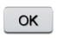, the system main menu is shown as below. You can operate and set each function in this menu.
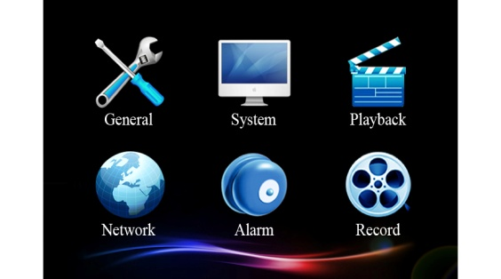
Picture 4.1 Main menu interface

4.1 Main menu navigation
Main menu | Function Overview
General | Set the basic parameters of the system
System | Update and maintain system and show related information of the system
Play | Search and play video files
Network | Set the basic parameters of the network
Alarm | Set the basic parameters of the alarm
Record | Set different record modes

4.2 General setup
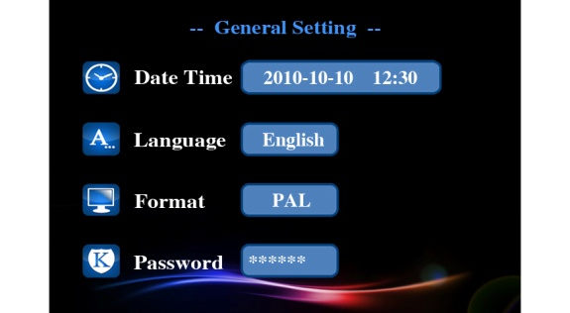
Picture 4.2 General setup interface
Set the basic parameters of the system, please click [main menu]> [general] to enter the general setup interface.
【Time setup】Set the system date and time.
【Language setup】Set the system language.
【Video format】 set the video format of the system According to PAL or NTSC used in different areas.
【Access password】Set the password of network remote monitor, the password only can be numbers; You must set access password for the system in the first time, otherwise the remote monitor can not be used.

4.3 System setup
Update and maintain the system, please click [main menu]> [system] to enter the general setup interface.

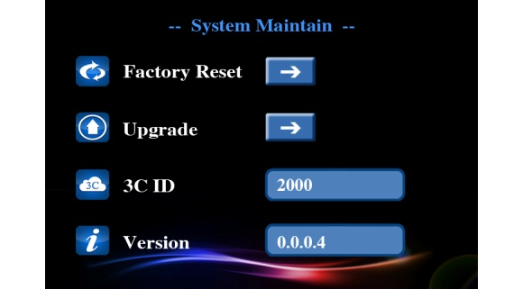
Picture 4.3 System setup interface
【Restore factory】Restore system to factory setting.
【System update】You can update and maintain the system when there is system software need to be updated. There are two ways: local update and cloud update. Local update: Copy the update file to U disk or Micro SD card, then insert U disk or Micro SD card, Press update buttonand then press buttonto update after system detect the update file, the system will reboot up after finish updating. Cloud update: Under network state, press the update button, then the system will automatically detect whether there is file need to be updated. Press button, the system will automatically upload and update after detect the new version .The system will reboot up after finish updating.
【3C ID】 The 3C ID number will be shown here after insert 3C smart card to the device.
【Version information】The current system version information is shown.

4.4 Play
Search and play video files, you can click [main menu]> [play] to enter the video playback interface.
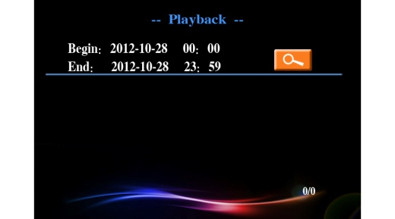
Picture 4.4 Video retrieval
【Fast retrieval】Enter the video playback interface, you can search system video file of the day after press search button directly. If there is no video, it will show “no video file found”.
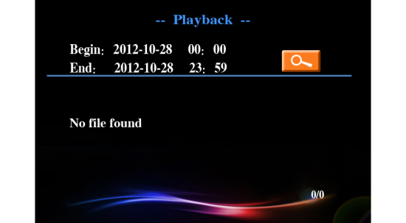
Picture 4.5 Video retrieval

【Accurate retrieval】Move the cursor to adjust the starting and ending time, the window will pop-up the video file list which conforms to searching condition after press search button , press up-down and left-right buttons to move the cursor to select the target file, then press buttonto play.
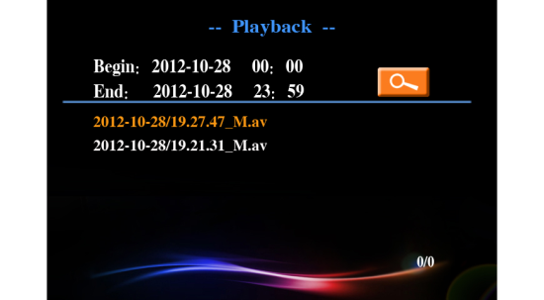
Picture 4.6 Video retrieval
【Play】During play state, press left-right buttons to finish fast forward and rewind operation and press up-down buttons to switch different video files. Press the buttonto stop playing. Press right key for single-frame playing during stop-playing state. Press button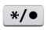or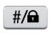can adjust the volume.
4.5 Network setup
Set network parameters,you can click [main menu]> [network] to enter the network setup interface.
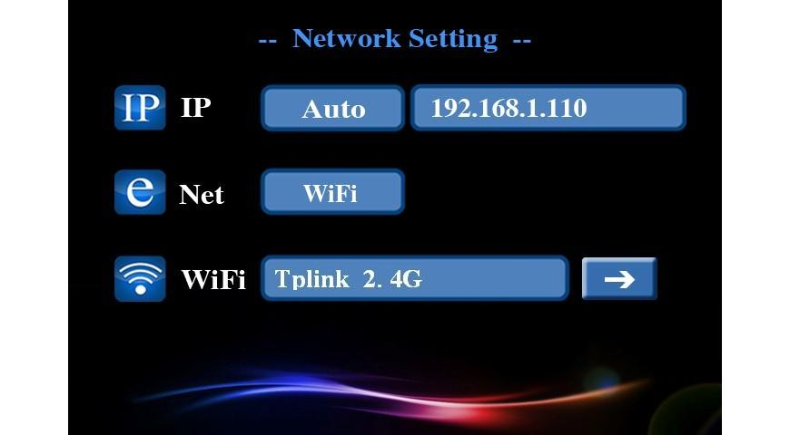
Picture 4.7 Network setup

【IP】Set system IP address, you can automatically or manually set the IP address. User should make sure enable router’s DHCP, otherwise it can not find IP address.
Through automatically set the IP address, system will automatic access to IP by DHCP; Through manually set the IP address, you can manually set the IP address(system will automatically determine the network segment of IP address, you only need manually set the last one of IP address. )
【Internet】According to access way to network to choose wired or WIFI connection to internet.

Equipped with wire, system will connect internet through the wired network; Using WIFI, system will search WIFI and set the connection accordingly, the connected internet name will be shown after successful access, and WIFI connection icon will be shown in standby interface.
Re: The function optional , some models without it , please notice 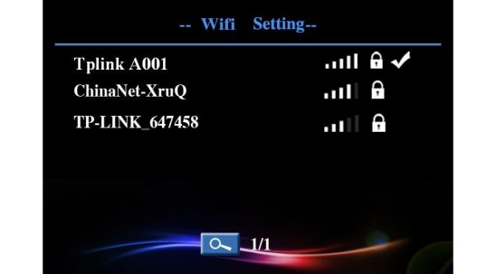
Picture 4.8 WIFI setup

4.6 Alarm setup
Set alarm parameters, you can click [main menu]> [alarm] to enter the alarm setup interface. You need pre-start the defence system before using alarm function, system enter defence state after long press button in 15 seconds, defence indicator will constant light.
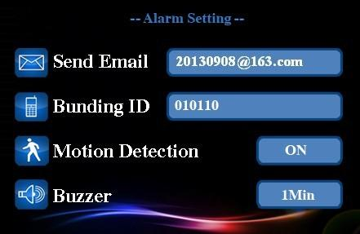
Picture 4.9 Alarm setup
【Send e-mail】When there is alarm or alarm linkage of capture images, system will send specific alarm information or capture images to the given e-mail address.
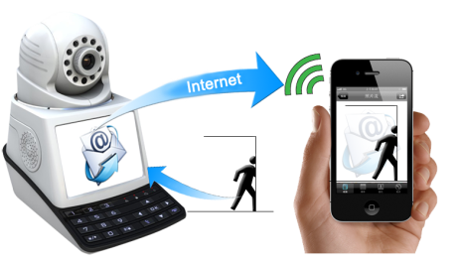
Picture 4.10 Email alarm
【Bunding ID】When the alarm occurs, system will send an alert to the given APP ID, when the user's APP receive the alert, you can remote monitor the site directly.
【Motion detection】This option is turned on and when the system detects the mobile signal that reached a preset sensitivity by analyzing the video image, motion detection alarm will be booted.
【Buzzer】You can set the alarm duration of system speaker when alarm appears.

4.7 Recording setup
Set different record modes, you can click [main menu]> [record] to enter the record setup interface. You can set three record modes: manual,alarm and timed.The priority of the manual recording is the highest, regardless of any recording modes, once long press button, it will enter manual recording mode.The record LED indicator will blink during record state.
【Manual】Long press record button can manually control the opening and closing.
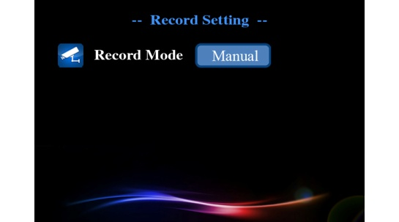
Picture 4.11 Record setup（1）
【Alarm】When motion detection or outside alarm triggers, system will automatically enter record state; Record timing indicates that record duration after trigger the alarm.
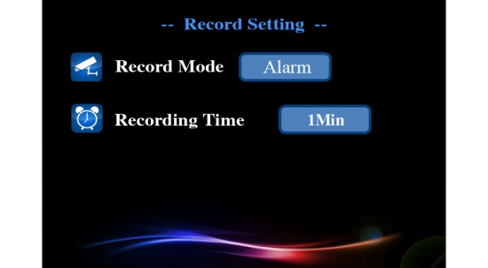
Picture 4.11 Record setup（2）

【Timed】You can set the record time, system will automatically enter record state during this time.
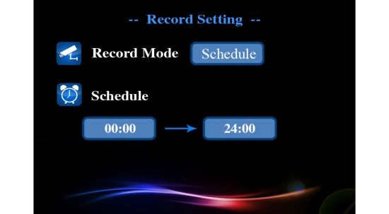
Picture 4.12 Record setup（3）

5 Remote monitor and video call
5.1 Remote monitor
You need correctly connect to the network before remote monitor. For network setup, please see 4.5 【Main menu】>【network setup】.

Remote monitor between two devices
The internet abnormal connection icon of standby interface will disappear after normal access to the internet, and the system is online state. Example: when using device A to make remote monitor to device B(the VAIP ID is 1001), you need set remote monitor password for device B(see 【Main menu】>【general】).And set device A as follows: press “1001#” and dial it, the dialog box will be popped up to remind you of entering access password, press confirm button after enter password, then device A can make remote monitor to device B.

Using cell phone or tablet to make remote monitor to the VAIP Phone Camera
You need download 2CU from APP Store in your mobile device first,, IOS clients can search and download 2cu from Apple APP Store, Android clients can search and download it from Google Play.
Boot up the application after normally installing 2CU client software to cell phone or tablet etc, click on the dial screen and enter the 3C ID as required, then click remote monitor button and the dialog box will be popped up to remind you of entering access password, you can make remote monitor to this VAIP Phone Camera after enter correct digital passwords; If the remote monitor fails, please check whether the network of mobile device is normal.
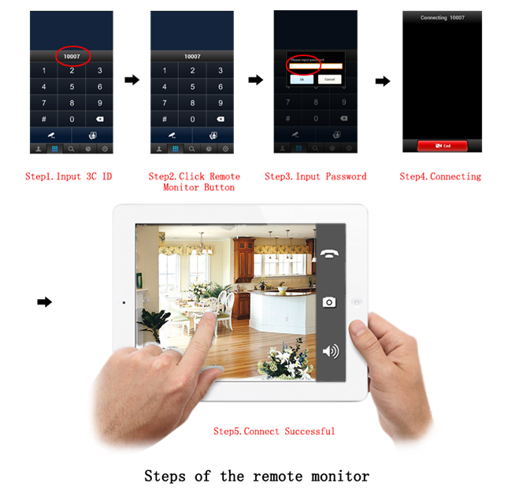
5.2 Video call
Video call between two devices
Dial among WAN network: After VAIP connecting to internet normally, the icon of standby abnormal network connection will disappear, the VAIP is online state, then you can make video calls after dial the 3C ID of the other device.

Dial among LAN network: If two devices in the same LAN,you can make video calls after dial the last numbers of the other IP address. For Example: the IP address of device A or device B in LAN is: 192.168.1.10 and 192.168.1.11, then device A can dial “11” to make video call with device B.

Using mobile devices such as cell phone or tablet computer to make video calls with the device.
Boot up the application after normally installing 2CU client software to cell phone or tablet computer etc, click on the dial screen and enter the 3C ID as required, click video call button to make video call with the VAIP; If the video call fails, please check whether the network of mobile device is available.
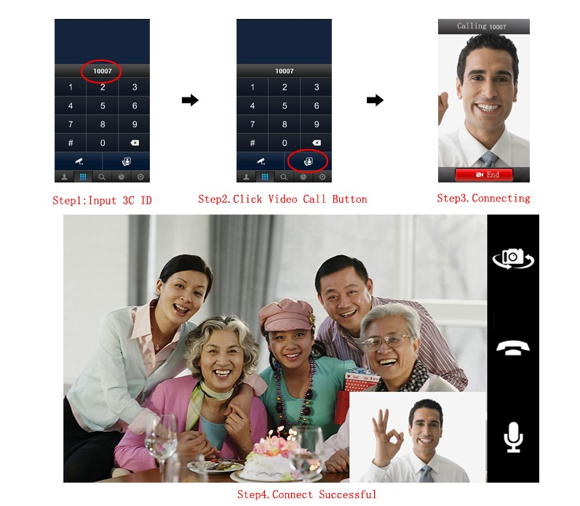
Steps of Video call

5.3 Recent call records and address book
Press dial button and enter recent call records interface under standby state:
Dial in, dial out, dial out but not connected, dial in but not connected, monitor, be monitored
Move the cursor and choose call records, press dial button can redial quickly; press OK button can add the numbers to address book.
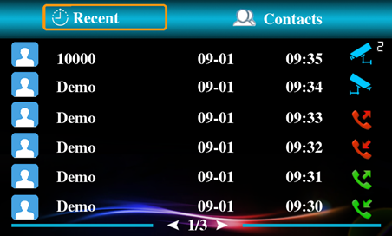
Move the cursor to address book and enter address book interface:
Move the cursor and choose the contact name, it can be modified through pressing OK button, long press OK button can delete the contact name.
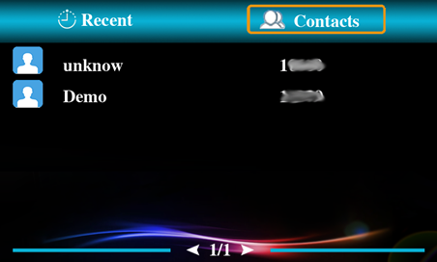

6 Wireless learning code

6.1 Learning code with Wireless detector and remote control.
All the wireless detectors must learn code with the device for normal usage. The specific operation as follows:
Please download and install APP from www.2cu.co, add the device to contact list after registration and successful login, click contact name->control->defense setup; for example to set up a door sensor as No. 1 detector of the hall, choose the hall, click No. 1 button, the learning code dialog box will be popped up, then the door sensor will be triggered and APP will remind that the learning is successful.
The No.1 button will turn to be light blue color.

6.2 Wireless detector & remote control
A. Delete a detector of a group of numbers: click the associated digital and confirm to delete.
B. Delete all detectors of a group of numbers: long press the group name and confirm to delete.

7 FAQ and maintenance
7.1 FAQ
If the problems you encounter are not listed, please contact local service or call the HQ service, we will try the best to serve you ASAP.

The VAIP cannot boot up normally.
Possible reasons as follows:
1.The input power supply is wrong.
2.Switch power supply line is not in good connection.
3.Switch power supply is damaged.
4.The program updating is wrong.
5.The front panel is damaged.
6. The main board is damaged.

The VAIP reboots automatically or stops working after boot up a few minutes
Possible reasons as follows:
1.The input voltage is not stable or too low.
2.The power of switch power supply is low.
3.Frontal video signal is not stable.
4.Bad heat radiator or too much dust or bad running circumstance of the VAIP.
5.The hardware of the VAIP is damaged.

System can not detect USB or Micro SD card
Possible reasons as follows:
1.The USB or Micro SD card is not in good connection.
2.The card slot is damaged.
3.The storage equipment is damaged.
4.The USB port of main board is damaged.

Can not find the video files in local playback mode.
Possible reasons as follows:
1.The storage equipment is damaged.
2.The query terms is wrong.
3.The video files to locate was covered.
4.The recording is not on.

The local video is not clear.
Possible reasons as follows:
1.The select image quality is too low.
2.The reading program is wrong, bit rate is low and full screen mosaic during playback. Normally the problem will be solved after reboot up the VAIP.
3.The storage equipment is damaged.
4.The hardware is damaged.

There is no audio signal in the surveillance window.
Possible reasons as follows:
1.It is not an active tone arm.
2.It is not an active sound box.
3.The audio lines are damaged.
4.The hardware of the VAIP is damaged.

The display time is wrong.
Possible reasons as follows:
1.Setting is wrong.
2.The battery is in bad connection or the voltage is too low.
3.The oscillation is damaged.
4. The hardware is damaged.

The motion detect does not work.
Possible reasons as follows:
1.The motion detect area setting is not correct.
2.The sensitivity is too low.
3.Limited by some hardware version.

The image is not clear or there is no image in network preview or video file playback state.
Possible reasons as follows:
1.Network is not stable.
2.The used machine is resource limited.
3.The user has no surveillance permission.

Network connection is not stable.
Possible reasons as follows:
1.Network is not stable.
2.IP address is conflicted.
3.MAC address is conflicted.
4.The network cad of the computer or the computer is bad.
7.2 Maintenance
Please use the VAIP in dry environment so that the VAIP can work long-term and stably. The damp dust in the circuit board will cause short-circuit which will interferes the VAIP normal running or damages the VAIP.
Please keep the grounding well done to prevent the video or audio signal interfered and the VAIP from static or inductive electricity.
Please keep the VAIP away from the heat resource.
Please keep the VAIP ventilated for better heat radiator.
Please check and maintain the system regularly.

Equipment updated in real time, there is no notice if upgraded.
If you have doubt or dispute for product description, all will be subjected to the ultimate interpretation of the company.
The manual is for the series products reference, the specific operation of each product is not an exhaustive; if you have any difficult problems, please contact the company customer service department.

7.3 Specification:
System | Operating system | Embedded Linux OS
Video | Image sensor | 0.3M pixels CMOS
Video | Video Compression Format | H.264
Video | Signal System | PAL/NTSC
Video | Video Resolution | VGA:640*480
Video | Recording Speed | VGA@ 25 fps or 30 fps
Video | Motion Detection | YES
Video | Minimum illumination | 0LUX/F1.2
Video | Video call | YES
Video | IR | YES
Video | Video output | BT656/3.5 inch TFT LCD
Audio | Compression | G.711A
Recording Manager | Recording Mode | Manual/Timer/Motion / Schedule
Recording Manager | Video Storage | USB、Micro SD
Alarm | Alarm Input(Optional) | Learning wireless sensor alarm input
Alarm | Alarm triggered | Speakers alarm、Alarm recording、Capture、Email
Others | Ethernet Interface | RJ45 100M / 1000M Base-TX
Others | USB / Micro SD | 1* USB 2.0 / 1* Micro SD
Others | Wifi(Optional) | YES，802.11 b/g/n
Others | Power Supply | DC 5V 2A
Others | PTZ Control | Built-in horizontal and vertical control motor
Others | Power Consumption | 2W
Others | Dimensions (mm) | 170*100*160mm
Others | Weight | 500g

